**Antonio “Chris” Palacios**

**Master’s Track and Field Champion & World Record Holder**

Imagine a work place, classroom or organization empowered by the passion to live greatness for

**“A Better You – A Better World – A Call to Action!”** Peak performers who enjoy what they do and achieve outstanding results because they have found the **“Why of their Passion”.** This is what this exciting, inspiring and entertaining speaker will bring to your meetings, conventions and special events when booked.

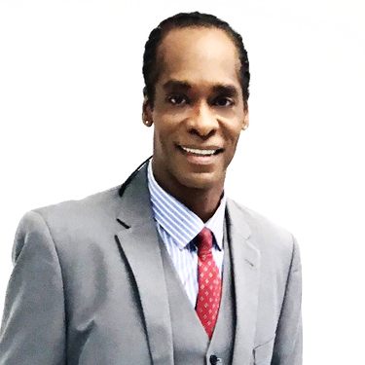**BIO:**

Antonio and his big brother Teddy, grew up on the Southside of Chicago raised by a very special single parent mother, Edwina Palacios (artist, community youthleader and track coach), and along with a father, Teodoro Palacios who was an Olympic high jumper for Guatemala, represent the roots of his “Passion for People” and drive for Greatness. This drive for greatness and love for people has been expressed in a multitude of life endeavors and achievements over the years.

**\* THE BE GREAT SPEAKER \***

Greatness as a young **Educator** (**1984-1987** Chicago Children’s Museum / supervisor), Track & field **Athlete** (**1985** USA JR. National triple jump Champion, **1987-1990** Big Ten All conference at Indiana University & **1992** Olympic trials long jump qualifier), **Model / Actor** & Pop music video artist / **Christopher.P.** (**1992-2000** Act One agency & CP. Productions), Track and Field **Coach** (**2000-2007** University of Chicago / Gwendolyn Brooks Academy), and for the past decade a top **Sales Agent** (**2008- to present** Bloom insurance agency); Antonio on his sales experience, ***“If you have a great product, it sales itself, and so when it came to being a speaker, for me it’s all about being the real deal, or Walk the walk, then Talk the talk.”***

**MASTER’S TRACK & FIELD ACCOMPLISHMENTS:**

Master’s Long jump World record holder + 12 time USA National Champion  **2012 USA MASTER ATHLETE OF THE YEAR**

**PRAISE FOR ANTONIO’S PRESENTATIONS:**

“I’ve seen Olympic long, high and triple jumps before but, it was your motivational speaking that really impressed me. The charisma, your passion and vision, brother you got the gift! Educator**: William Kazee**

**KEYNOTE PROGRAMS / 45m:**

**\*The Will to Win 7Ws to Greatness**

Whether you’re in the corporate world, the classroom or on the playing field, you’ll need the greatness of the “WILL TO WIN” to achieve success.

**\* We can’t wait! The world calls to us to be great!**

Antonio speaks on unlocking that greatness within us, not only as a means of improving our own lives, but also as a way to answer a world that cries out for the best from all of us.

**\* Fitness for Life**

Here he shares his mental approach to fitness, along with eating and training systems he’s used to help him.

**WEBSITE:** [**www.acpspeaks.com**](http://www.acpspeaks.com)